**Practical 5**

**Aim:- Configure and Verify Path Control Using PBR**

**Topology:-**

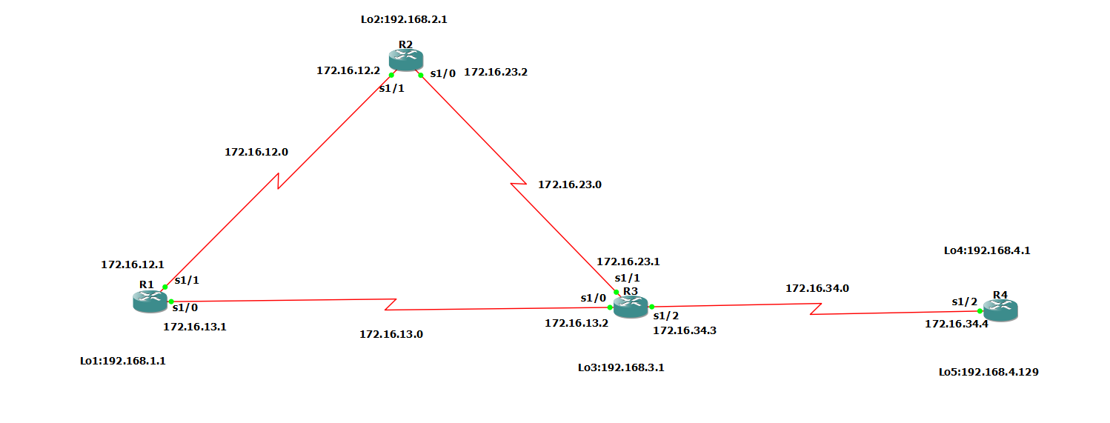

**Step 1:- Configure loopbacks and assign addresses.**

a)Cable the network as shown in the topology diagram. Erase the startup configuration, and reload each router to clear previous configurations.

b) Using the addressing scheme in the diagram, create the loopback interfaces and apply IP addresses to these and the serial interfaces on R1, R2, R3, and R4. On the serial interfaces connecting R1 to R3 and R3 to R4, specify the bandwidth as 64 Kb/s and set a clock rate on the DCE using the clock rate 64000 command. On the serial interfaces connecting R1 to R2 and R2 to R3, specify the bandwidth as 128 Kb/s and set a clock rate on the DCE using the clock rate 128000 command.

**Router R1 Console**

conf t

hostname R1

interface Lo1

description R1 LAN

ip address 192.168.1.1 255.255.255.0

exit

interface Serial1/1

description R1 --> R2

ip address 172.16.12.1 255.255.255.248

clock rate 128000

bandwidth 128

no shutdown

exit

interface Serial1/0

description R1 --> R3

ip address 172.16.13.1 255.255.255.248

bandwidth 64

no shutdown

exit

end

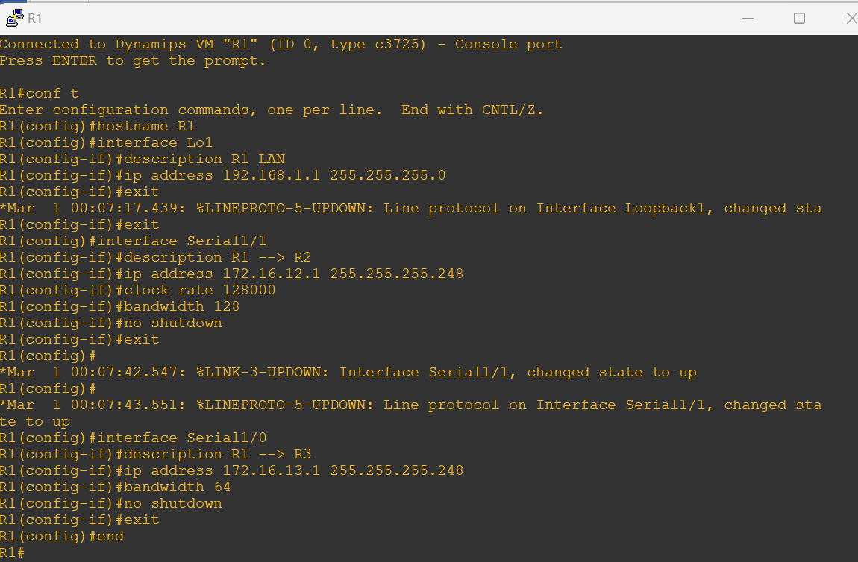

**Router R2 Console**

conf t

hostname R2

interface Lo2

description R2 LAN

ip address 192.168.2.1 255.255.255.0

exit

interface Serial1/1

description R2 –> R1

ip address 172.16.12.2 255.255.255.248

bandwidth 128

no shutdown

exit

interface Serial1/0

description R2 --> R3

ip address 172.16.23.2 255.255.255.248

clock rate 128000

bandwidth 128

no shutdown

exit

end

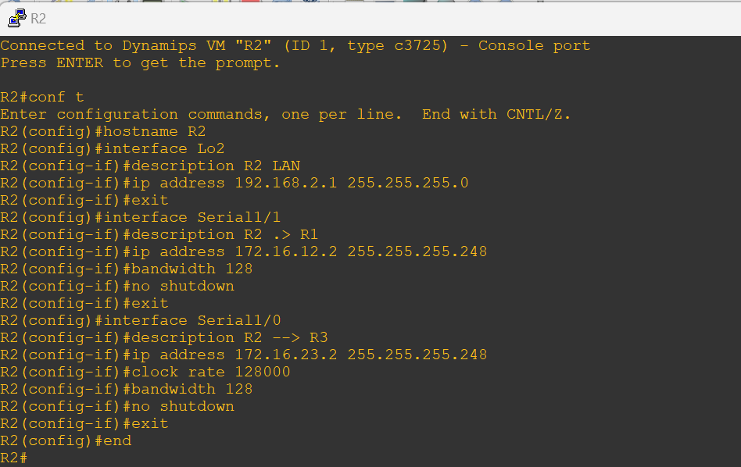

**Router R3 Console**

hostname R3

interface Lo3

description R3 LAN

ip address 192.168.3.1 255.255.255.0

exit

interface Serial1/0

description R3 --> R1

ip address 172.16.13.3 255.255.255.248

clock rate 64000

bandwidth 64

no shutdown

exit

interface Serial1/1

description R3 --> R2

ip address 172.16.23.3 255.255.255.248

bandwidth 128

no shutdown

exit

interface Serial1/2

description R3 --> R4

ip address 172.16.34.3 255.255.255.248

clock rate 64000

bandwidth 64

no shutdown

exit

end

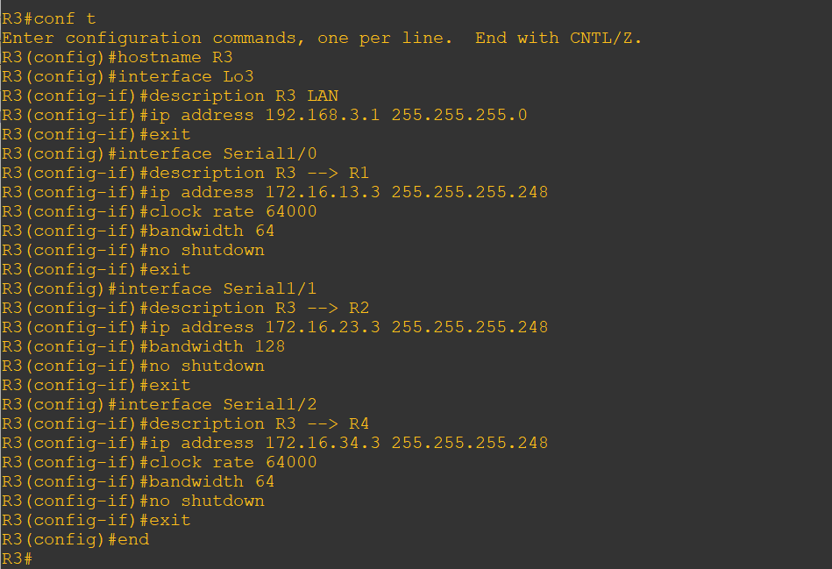

**Router R4 Console**

conf t

hostname R4

interface Lo4

description R4 LAN A

ip address 192.168.4.1 255.255.255.128

exit

interface Lo5

description R4 LAN B

ip address 192.168.4.129 255.255.255.128

exit

interface Serial1/2

description R4 --> R3

ip address 172.16.34.4 255.255.255.248

bandwidth 64

no shutdown

exit

end

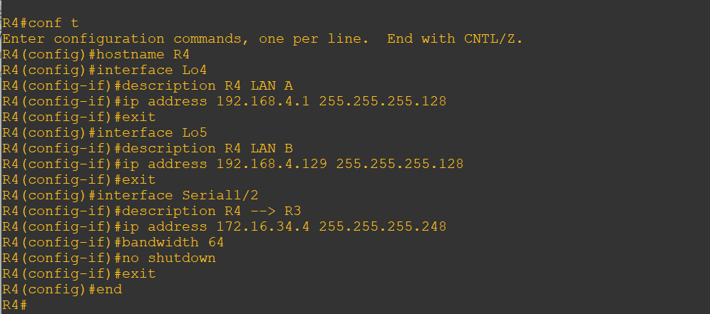

c) Verify the configuration with the show ip interface brief, show interfaces description commands. The output from router R3 is shown below.

Router R3 Console

show ip interface brief | include up

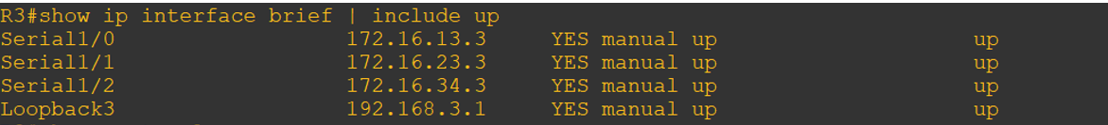

show interfaces description | include up

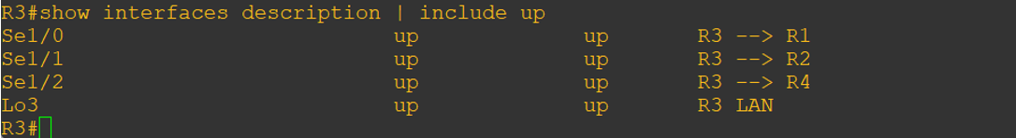

Step 3:- Configure basic EIGRP

a) Implement EIGRP AS 1 over the serial and loopback interfaces as you have configured it for the other EIGRP labs.

b) Advertise networks 172.16.12.0/29, 172.16.13.0/29, 172.16.23.0/29, 172.16.34.0/29, 192.168.1.0/24, 192.168.2.0/24, 192.168.3.0/24, and 192.168.4.0/24 from their respective routers.

**Router R1 Console**

conf t

router eigrp 1

network 192.168.1.0

network 172.16.12.0 0.0.0.7

network 172.16.13.0 0.0.0.7

no auto-summary

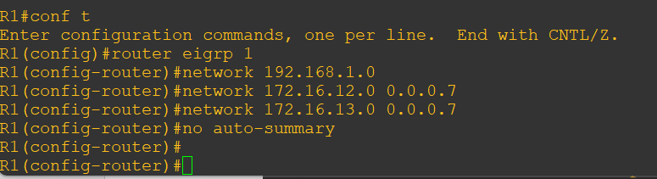

**Router R2 Console**

conf t

router eigrp 1

network 192.168.2.0

network 172.16.12.0 0.0.0.7

network 172.16.23.0 0.0.0.7

no auto-summary

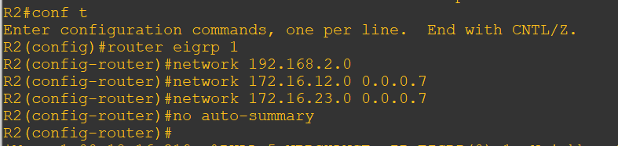

**Router R3 Console**

conf t

router eigrp 1

network 192.168.3.0

network 172.16.13.0 0.0.0.7

network 172.16.23.0 0.0.0.7

network 172.16.34.0 0.0.0.7

no auto-summary

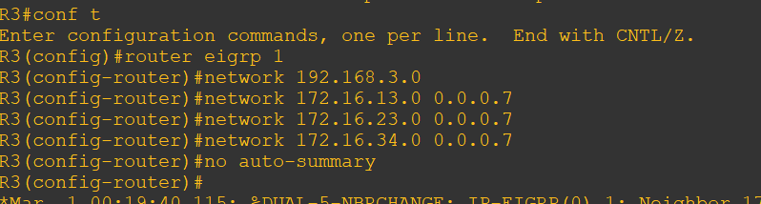

**Router R4 Console**

conf t

router eigrp 1

network 192.168.4.0

network 172.16.34.0 0.0.0.7

no auto-summary

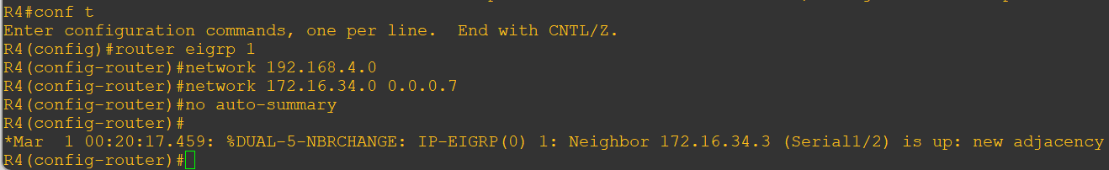

**Step 4:- Verify EIGRP connectivity.**

a) Verify the configuration by using the **show ip eigrp neighbors** command to check which routers have EIGRP adjacencies.

**Router R1 Console**

show ip eigrp neighbors

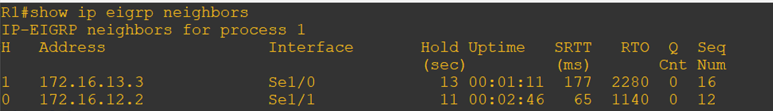

**Router R2 Console**

show ip eigrp neighbors

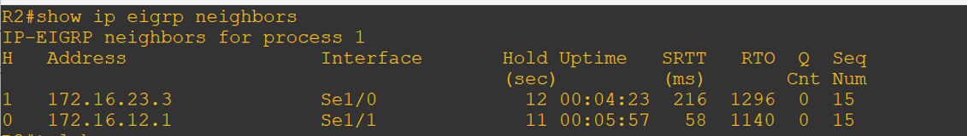

**Router R3 Console**

show ip eigrp neighbors

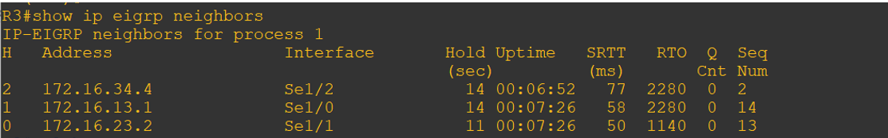

**Router R4 Console**

show ip eigrp neighbors

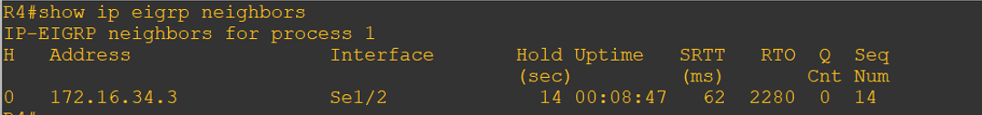

b) Run the following Tcl script on all routers to verify full connectivity.

**Router R1 Console**

tclsh

foreach address {

172.16.12.1

172.16.12.2

172.16.13.1

172.16.13.3

172.16.23.2

172.16.23.3

172.16.34.3

172.16.34.4

192.168.1.1

192.168.2.1

192.168.3.1

192.168.4.1

192.168.4.129

} { ping $address }

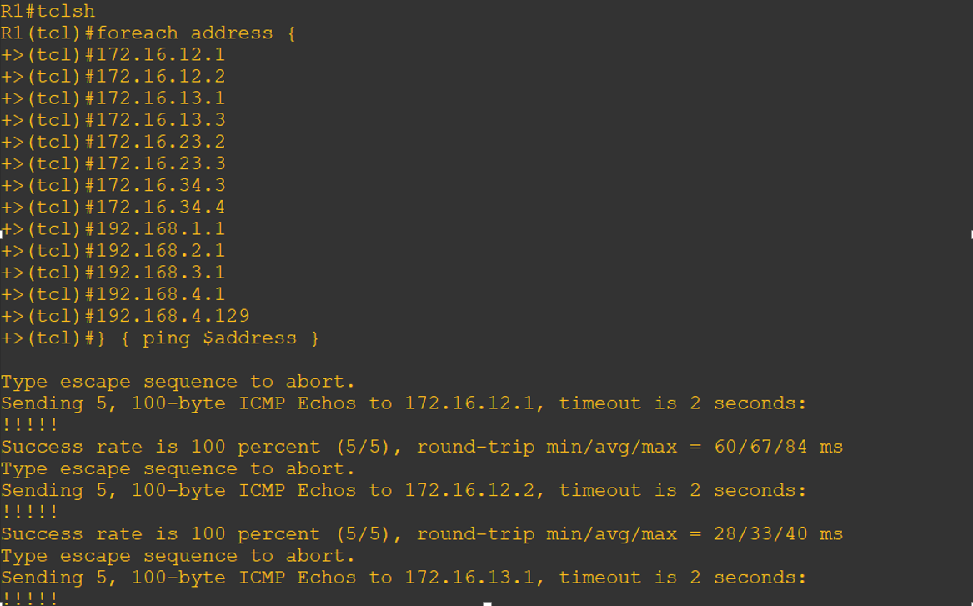

**Step 5:- Verify the current path.**

Before you configure PBR, verify the routing table on R1.

a) On R1, use the show ip route command. Notice the next-hop IP address for all networks discovered by EIGRP.

**Router R1 Console**

show ip route | begin Gateway

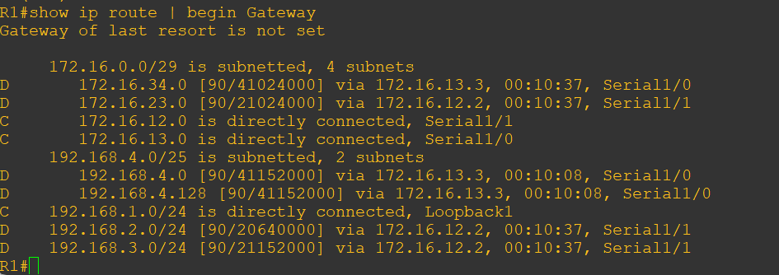

b) On R4, use the traceroute command to the R1 LAN address and source the ICMP packet from R4 LAN A and LAN B.

**Router R4 Console**

traceroute 192.168.1.1 source 192.168.4.1

traceroute 192.168.1.1 source 192.168.4.129

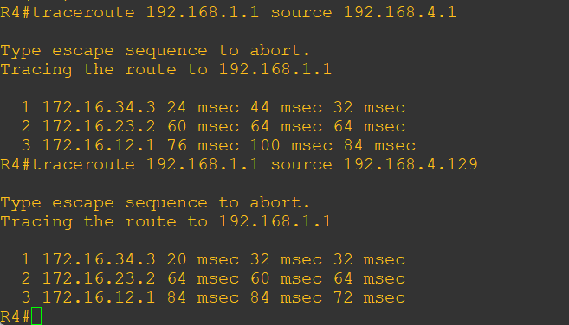

Notice that the path taken for the packets sourced from the R4 LANs are going through R3 🡪 R2 🡪R1.

c) On R3, use the show ip route command and note that the preferred route from R3 to R1 192.168.1.0/24 is via R2 using the R3.

**Router R3 Console**

show ip route | begin Gateway

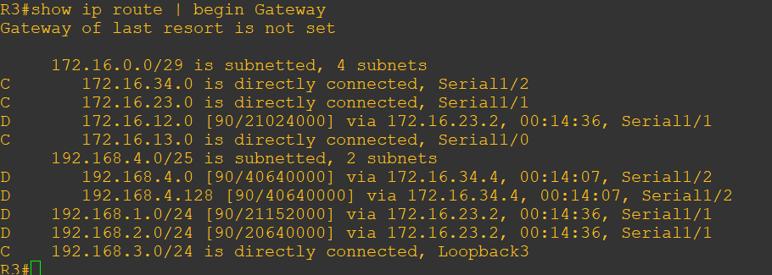

d) On R3, use the **show interfaces S1/0** and **show interfaces S1/1** commands.

Router R3 Console

show interfaces serial1/0

show interfaces serial1/0 | include BW

show interfaces serial1/1 | include BW

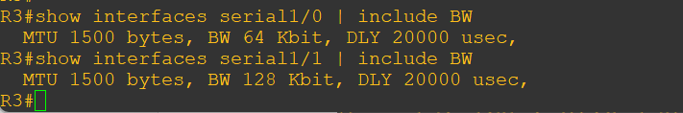

Notice that the bandwidth of the serial link between R3 and R1 (S1/3) is set to 64 Kb/s, while the bandwidth of the serial link between R3 and R2 (S1/1) is set to 128 Kb/s.

e) Confirm that R3 has a valid route to reach R1 from its serial 0/0/0 interface using the **show ip eigrp topology 192.168.1.0** command.

**Router R3 Console**

show ip eigrp topology 192.168.1.0

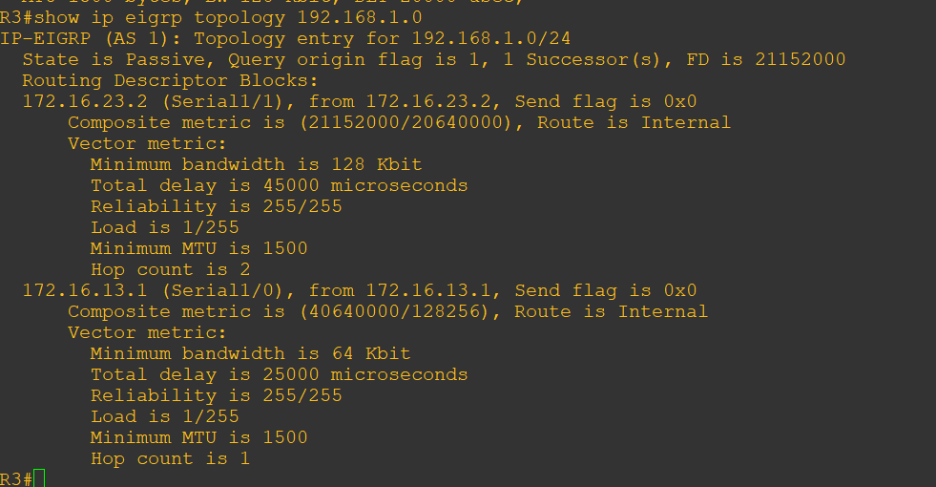

As indicated, R4 has two routes to reach 192.168.1.0. However, the metric for the route to R1 (172.16.13.1) is much higher (40640000) than the metric of the route to R2 (21152000), making the route through R2 the successor route.

**Step 6:- Configure PBR to provide path control.**

Now you will deploy source-based IP routing by using PBR. You will change a default IP routing decision based on the EIGRP-acquired routing information for selected IP source-todestination flows and apply a different next-hop router.

Recall that routers normally forward packets to destination addresses based on information in their routing table. By using PBR, you can implement policies that selectively cause packets to take different paths based on source address, protocol type, or application type. Therefore, PBR overrides the router’s normal routing behavior.

Configuring PBR involves configuring a route map with match and set commands and then applying the route map to the interface.

a) On router R3, create a standard access list called **PBR-ACL** to identify the R4 LAN B network.

**Router R3 Console**

conf t

ip access-list standard PBR-ACL

remark ACL matches R4 LAN B traffic

permit 192.168.4.128 0.0.0.127

exit

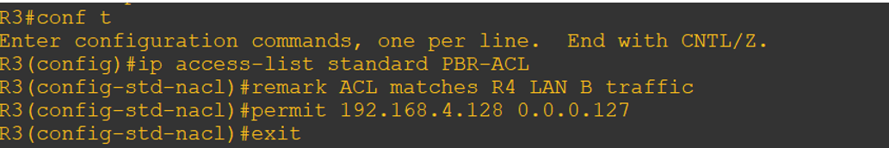

b) Create a route map called R3-to-R1 that matches PBR-ACL and sets the next-hop interface to the R1 S1/1 interface.

**Router R3 Console**

route-map R3-to-R1 permit

description RM to forward LAN B traffic to R1

match ip address PBR-ACL

set ip next-hop 172.16.13.1

exit

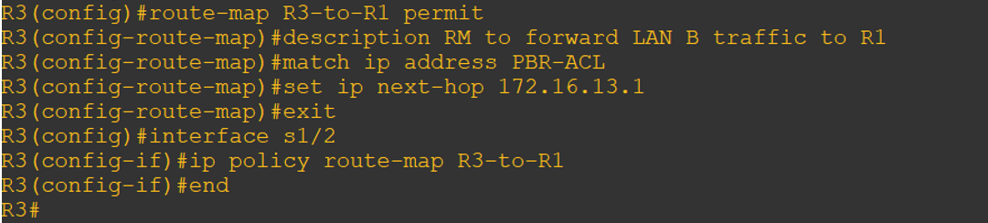

c) Apply the R3-to-R1 route map to the serial interface on R3 that receives the traffic from R4. Use the ip policy route-map command on interface S1/2.

**Router R3 Console**

conf t

interface s1/2

ip policy route-map R3-to-R1

end

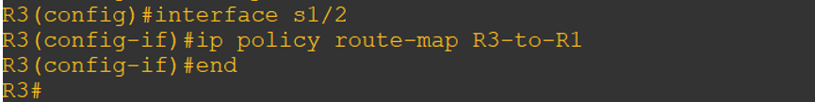

d) On R3, display the policy and matches using the **show route-map** command.

**Router R3 Console**

show route-map

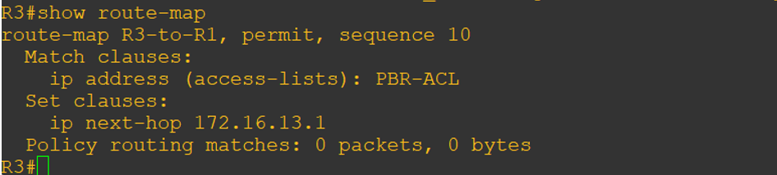

Note:- There are currently no matches because no packets matching the ACL have passed through R3 S1/2.

**Step 7:- Test the policy.**

Now we are ready to test the policy configured on R3. Enable the debug ip policy command on R3 so that you can observe the policy decision-making in action. To help filter the traffic, first create a standard ACL that identifies all traffic from the R4 LANs

a) On R3, create a standard ACL which identifies all of the R4 LANs.

**Router R3 Console**

conf t

access-list 1 permit 192.168.4.0 0.0.0.255

exit

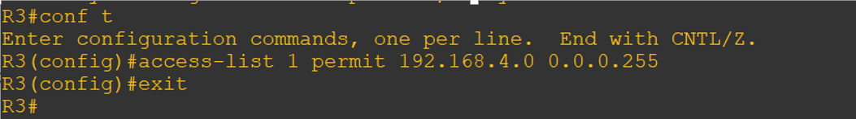

b) Enable PBR debugging only for traffic that matches the R4 LANs.

**Router R3 Console**

debug ip policy ?

debug ip policy 1

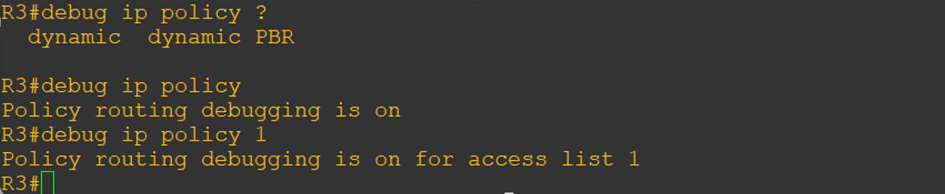

c) Test the policy from R4 with the traceroute command, using R4 LAN A as the source network.

Router R4 Console

traceroute 192.168.1.1 source 192.168.4.1

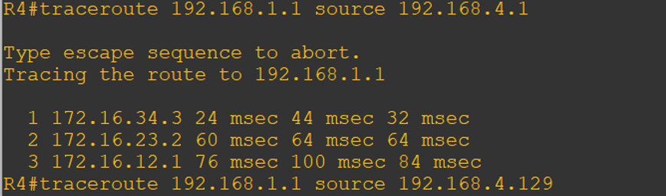

Notice the path taken for the packet sourced from R4 LAN A is still going through R3 🡪 R2 🡪 R1.

As the traceroute was being executed, router R3 should be generating the following debug output.

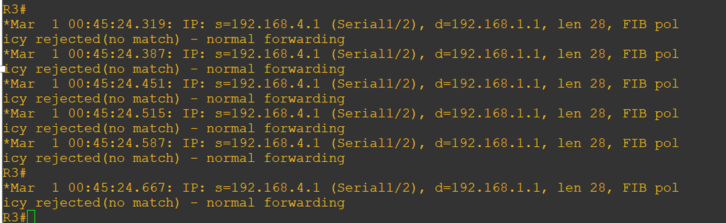

d) Test the policy from R4 with the traceroute command, using R4 LAN B as the source network.

Router R4 Console

traceroute 192.168.1.1 source 192.168.4.129

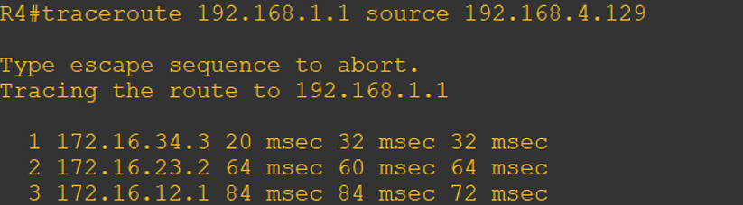

Now the path taken for the packet sourced from R4 LAN B is R3 🡪 R1, as expected.

The debug output on R3 also confirms that the traffic meets the criteria of the R3-to-R1 policy.

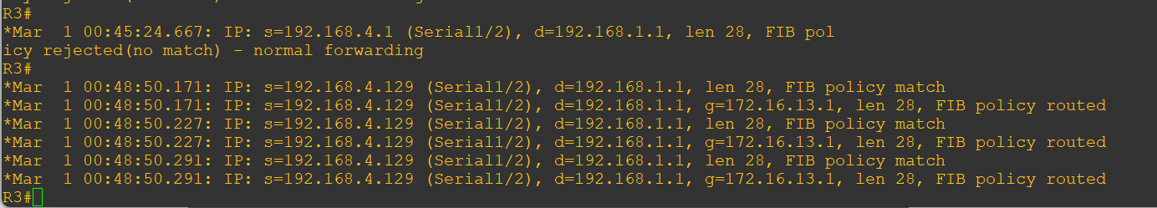

e) On R3, display the policy and matches using the show route-map command.

Router R3 Console

show route-map

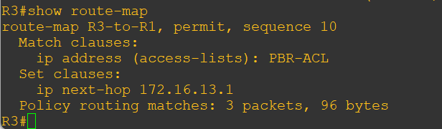

Note:- There are now matches to the policy because packets matching the ACL have passed through R3 S1/2.